1. How do we represent data? Name two different data types and their standards.
2. A signal with 300 milliwatts power passes through 5 devices, each with an average noise of 2 microwatts. What is the SNR? What is the SNRdB?
3. Which layer(s) are involved in encrypting the data of a packet? Which address(es) does not change at each hop?
4. Complete the frames (x & y) given below with appropriate port, IP and MAC addresses. The sender Host E has two applications running; one for email with port number 49170 and the other for accessing the web server with port number 51033. The frame x is intended for the BRACU Web server and frame y is coming from the Email Server. (MAC addresses are alphabets and IP addresses are numbers)

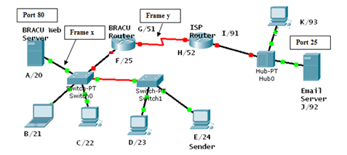

Frame X

| D. Mac | S. MAC | D. IP | S. IP | D. Port | S. Port | Data | Trailer |
| --- | --- | --- | --- | --- | --- | --- | --- |

Frame Y

| D. Mac | S. MAC | D. IP | S. IP | D. Port | S. Port | Data | Trailer |
| --- | --- | --- | --- | --- | --- | --- | --- |

1. Between a high SNR and a low SNR, which one is more desirable? Explain why.
2. Write the differences between baseline wandering and DC component and its effect on digital transmission.
3. The figure below represents the Differential Manchester encoding of a data stream. What is the data stream? D. Manchester does not require block coding, explain briefly.

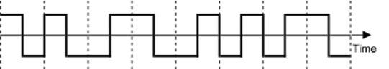

1. Differential Manchester solves a number of common problems that occur in signal encoding processes, what are they and how are they solved?
2. What is the **advantage** and **disadvantage** of using Block Coding signal encoding technique? Convert the Data 1000011010101011001 into signal using 4B/5B block coding technique with MLT-3 line coding scheme. The table below shows the substitution of blocks.

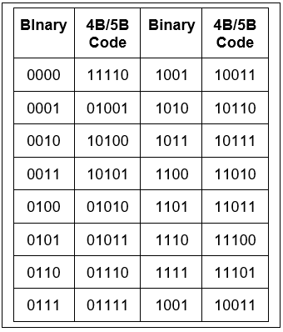

1. Define PCM. Explainthe PCM quantization technique of an analog signal with appropriate diagram and calculation.